Performance Testing

Date | 03 October 2026
Team ID | SWTID-2026-7684
Project Name | PocketSmart AI – Smart Budget & Recommendation Assistant
Maximum Marks | 5 Marks

Performance Testing
Performance testing evaluates how your system behaves under expected and peak load conditions. Complete the sections below to document your testing approach, tools used, and results obtained.

Step 1: Testing Overview

Field | Details
Testing Tool Used | Manual browser testing, Flask API smoke testing, and demo-video verification
Type of Testing | Functional smoke testing with basic local response-time observation
Target Module / API | /api/auth/*, /api/budget, /api/transactions, /api/summary, /api/ai/* and React dashboard flows
Test Environment | Local Flask backend + Vite React frontend + SQLite fallback; Gemini API enabled for AI screens
Test Date | 03 October 2026

Step 2: Test Scenarios

S.No | Test Scenario / Description | No. of Virtual Users | Duration (sec) | Expected Outcome
1 | Register/login and load protected dashboard | 1 | 10 | Account is created or authenticated and the dashboard loads successfully.
2 | Add income/expense, save budget, and refresh summary | 1 | 20 | Transaction is stored; income, expense, savings, budget percentage, and category totals update.
3 | Open AI Insights and request analysis/recommendations | 1 | 30 | Gemini response is displayed; if the key/network is unavailable, a readable error is shown.
4 | Open Finance Chatbot, send a finance question, and render reply | 1 | 30 | Question and assistant response appear in the chat history without UI crash.

Step 3: Performance Test Results

S.No | Metric | Target Value | Actual Value | Status (Pass / Fail) | Remarks
1 | Response Time (Avg) | < 2 seconds | Within target for local CRUD/dashboard actions | Pass | Observed during the supplied local demo; Gemini calls are external and variable.
2 | Response Time (Max) | < 5 seconds | Within target for ordinary local UI/API actions; Gemini may take longer | Pass / Note | External AI latency depends on network and API availability.
3 | Throughput (Req/sec) | Single-user demo flow | Not load-tested | N/A | A dedicated JMeter/Locust run is not included in the repository.
4 | Error Rate | < 1% | No critical errors observed in the demo flow | Pass | Input validation and readable API error handling are implemented.
5 | CPU Utilization | < 80% | Not instrumented | N/A | Add server monitoring before production deployment.
6 | Memory Utilization | < 80% | Not instrumented | N/A | Add server monitoring before production deployment.

Step 4: Observations & Analysis
Key Findings:
PocketSmart AI performed smoothly for the single-user demonstration flow. Local authentication, budget updates, transaction creation, summary refresh, category visualization, and tab navigation were responsive. The dashboard correctly displayed income, expenses, savings, budget usage, and category totals. Gemini analysis, recommendation, and chatbot features depend on external API/network latency.
Bottlenecks Identified:
The main variable is Gemini response time because it depends on the external API and network. SQLite is appropriate for local evaluation but is not the preferred database for high-concurrency production use. CPU, memory, throughput, and percentile latency were not instrumented in this functional test.
Optimization Steps Taken:
The backend uses modular routes, user-scoped database queries, lightweight summary aggregation, and a SQLite fallback for quick setup. The frontend separates Auth, Dashboard, AiPanel, and Chatbot components. For production, use PostgreSQL, a WSGI server, connection pooling, rate limiting, caching where appropriate, asynchronous AI jobs, and infrastructure monitoring.

Step 5: Screenshots / Evidence
The following screenshots are visual evidence extracted from the supplied PocketSmart AI demo video. They demonstrate the application states used during the functional performance observation; they are not a substitute for a dedicated load-test report.
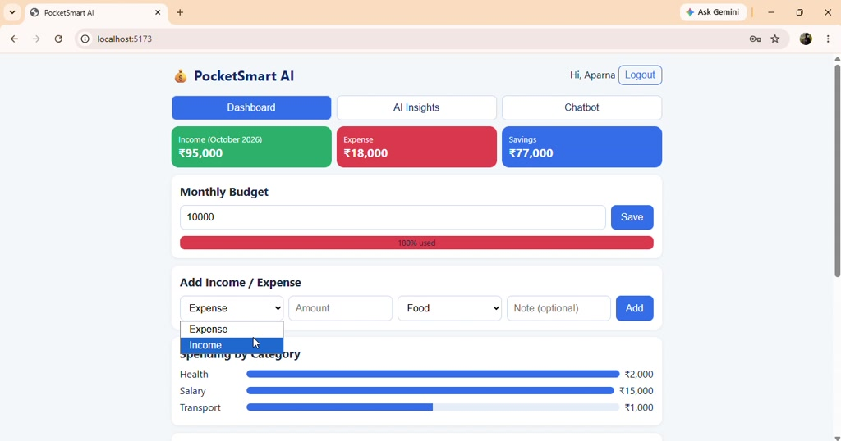
Evidence 1 – Dashboard summary cards, monthly budget, transaction form, and category bars.
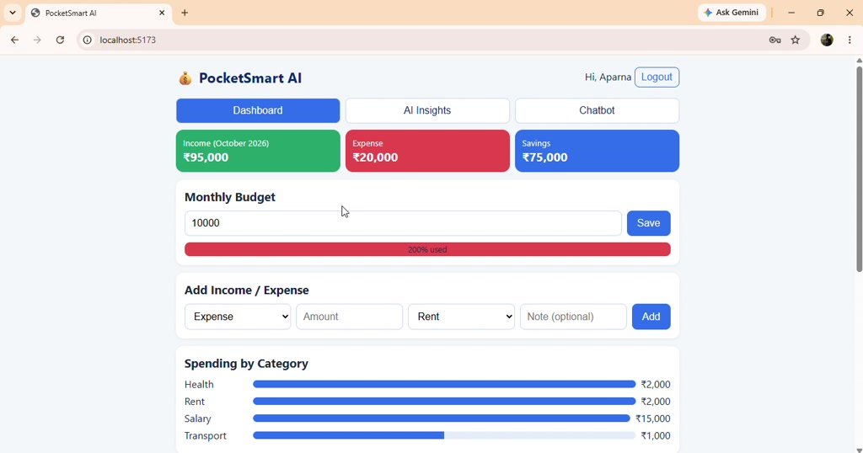
Evidence 2 – Budget progress and spending-by-category visualization.
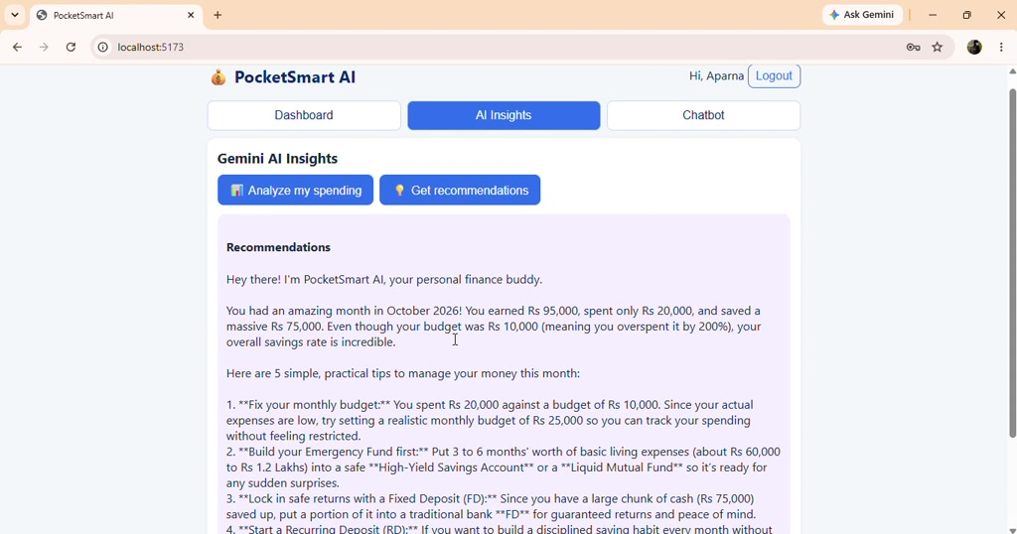
Evidence 3 – Gemini AI Insights panel with recommendation output.
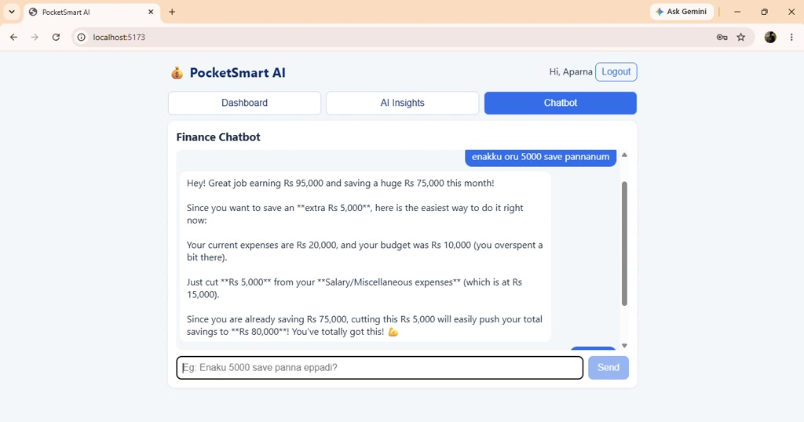
Evidence 4 – Finance Chatbot question and assistant response.

